Write a program that accepts the job_id as argument and returns a custom counter and a system counter (total records input to the map tasks) associated with that job.

**DRIVER CLASS:**

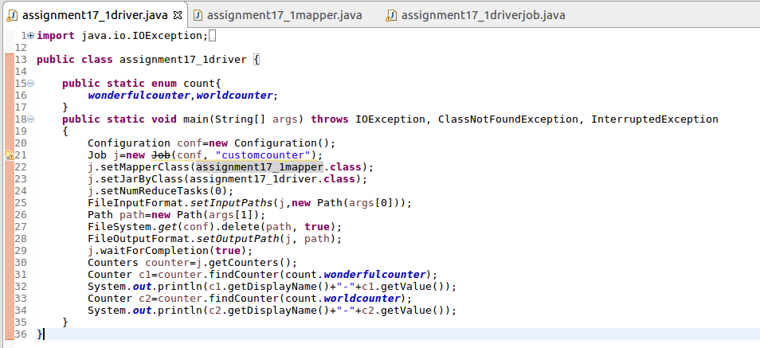

**MAPPER CLASS:**

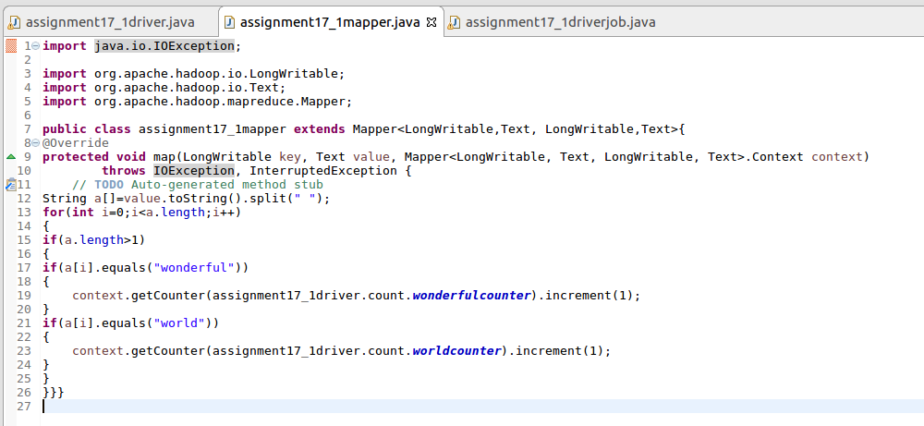

**RUNNING JAR:**

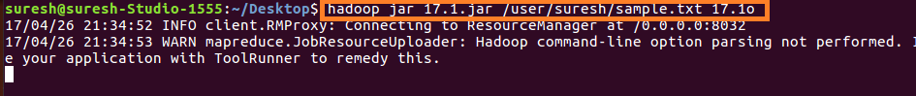

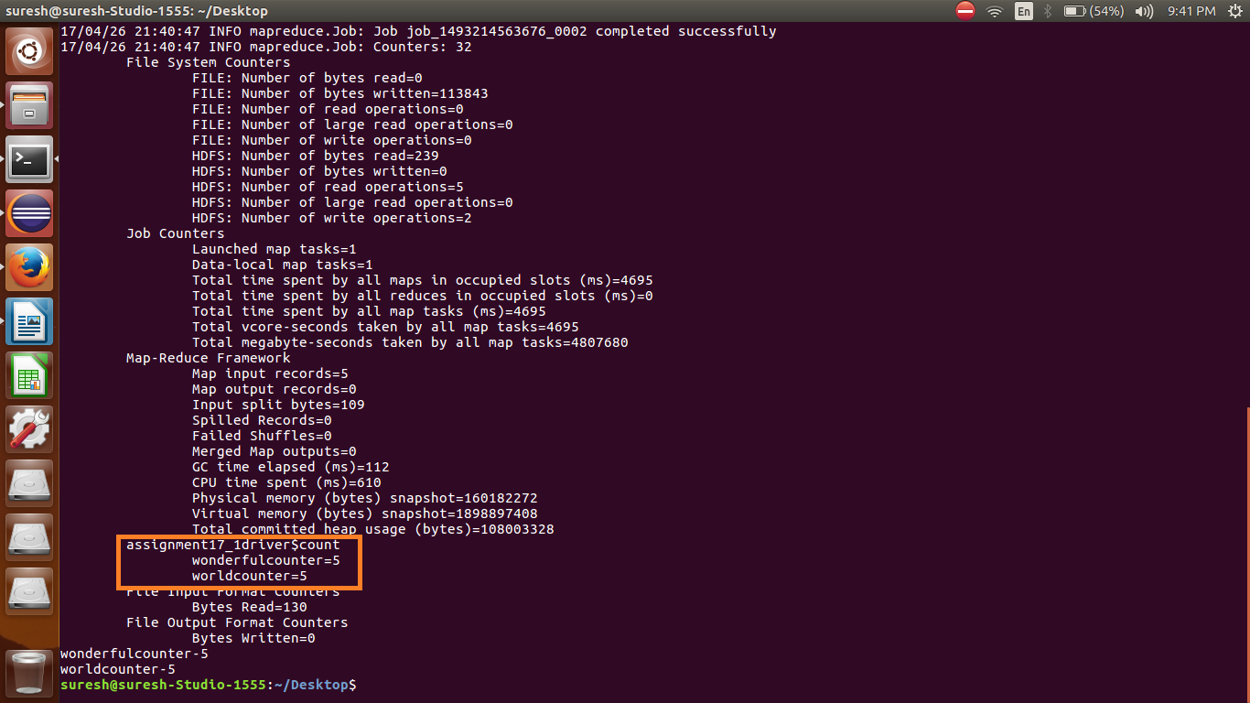

**OUTPUT:**

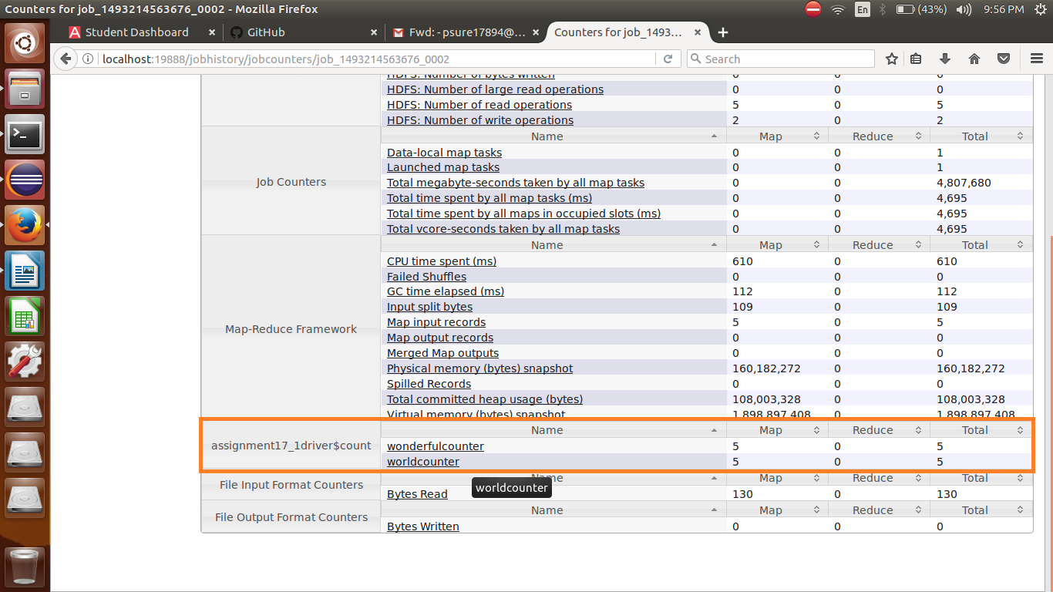

**JOB ID:**

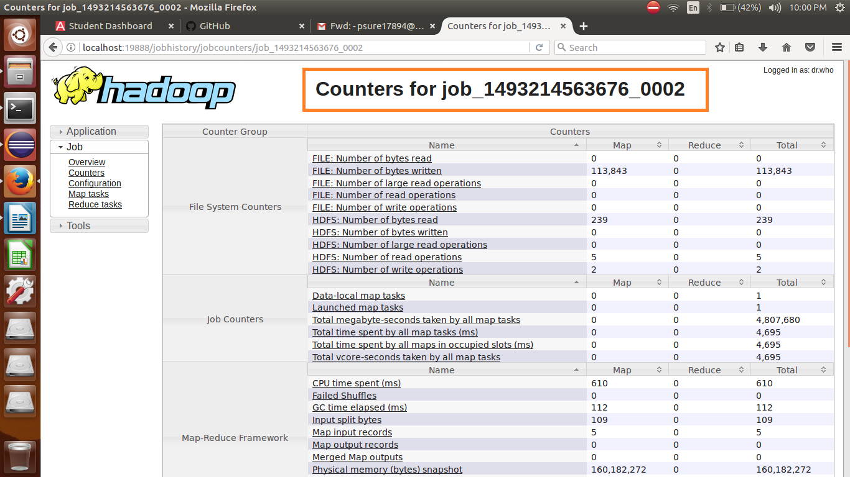

**DRIVER CLASS FOR GIVING JOB ID AS ARGUMENT:**

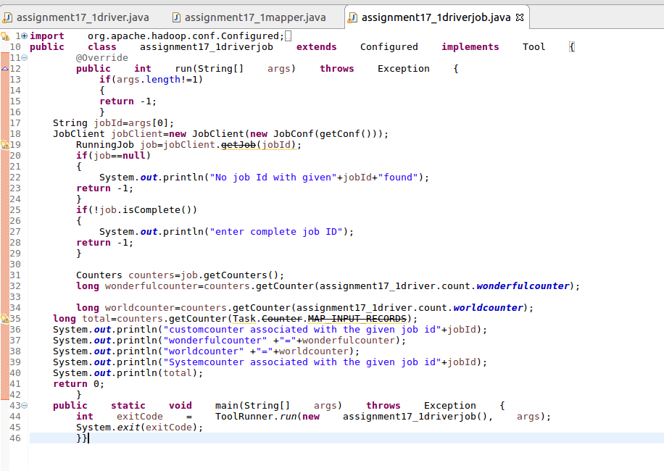

**RUNNING JAR AND OUTPUT:**

